## Procedure:

1. Create x-y coordinate tracks of acceleration, skid pad, autocross and endurance
2. Add setting to determine which track the vehicle will run
3. Create function that can determine error between what the car is doing, and what it should be doing. Nearby track that is not actually where the vehicle needs to go should not break algorithm.
4. Create controller to minimize error when vehicle is in equal torque mode

## In General:

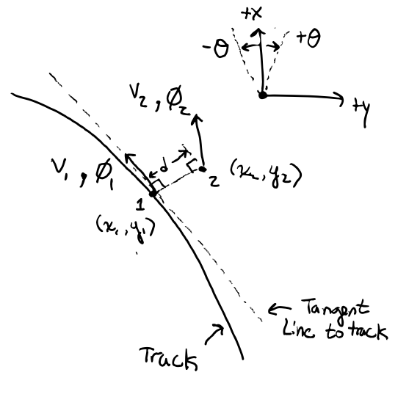

## Subject To:

$$given=\left\{V_{2x},V_{2y},ϕ_{2},x_{2},y_{2}\right\}$$

$$\left(x_{1},y_{1}\right)=f(\min\left(d\right))$$

$$ϕ_{1}=f(x_{1}, y_{1})$$

$$V_{1}=f(x_{1}, y_{1})$$

$$V_{2}=\sqrt[2]{{V_{2x}}^{2}+{V_{2y}}^{2}}$$

## Find:

$$∆V=V_{1}-V_{2}$$

$$Δϕ=ϕ_{1}-ϕ_{2}$$

$$∆d=\sqrt[2]{{\left(x_{2}-x_{1}\right)}^{2}+{\left(y_{2}-y_{1}\right)}^{2}}$$